ELECENG 3EJ4
Lab Report #1
Instructor: Dr. Chen
Jasmine Dosanjh – dosanj5 – 400531879
September 21, 2025

Part 1 Questions
Q1. (7 Points)
(1) $V_{BEon}=0.621V$, $I_{B}=8.79×{10}^{-6}A=8.79μA$
(2) $β=117$
(3) $\left|V_{A}\right|=1000V$
(4) $r_{o}=9.76×{10}^{5}Ω×\frac{1kΩ}{{10}^{3}Ω}=9.76×{10}^{2}kΩ=976kΩ$
(5) $g_{m}=4.1×{10}^{-2}S×\frac{1mS}{{10}^{-3}S}=41mS$
(6) $r_{π}=2845Ω×\frac{1kΩ}{{10}^{3}Ω}=2.845kΩ$

Q2. (8 Points)
(1) $I_{C}=2.32×{10}^{-3}A=2.32mA$
(2) $V_{BEon}=0.67854V$, $I_{B}=8.21×{10}^{-6}A=8.21μA$
(3) $β=283$
(4) $\left|V_{A}\right|=55V$
(5) $r_{o}=2.73×{10}^{4}Ω×\frac{1kΩ}{{10}^{3}Ω}=2.73×{10}^{1}kΩ=27.3kΩ$
(6) $g_{m}=9.29×{10}^{-2}S×\frac{1mS}{{10}^{-3}S}=92.9mS$
(7) $r_{π}=3043Ω×\frac{1kΩ}{{10}^{3}Ω}=3.043kΩ$

Part 2 Questions
Q3. (7 Points)
(1) $V_{BEon}=0.660V$, $I_{B}=8.40×{10}^{-6}A=8.40μA$
(2) $β=123$
(3) $\left|V_{A}\right|=143V$
(4) $r_{o}=1.39×{10}^{5}Ω×\frac{1kΩ}{{10}^{3}Ω}=1.39×{10}^{2}kΩ=139kΩ$
(5) $g_{m}=4.12×{10}^{-2}S×\frac{1mS}{{10}^{-3}S}=41.2mS$
(6) $r_{π}=2976Ω×\frac{1kΩ}{{10}^{3}Ω}=2.976kΩ$

Q4. (8 Points)
(1) $I_{C}=4.02×{10}^{-3}A=4.02mA$
(2) $V_{BEon}=0.601V$, $I_{B}=8.99×{10}^{-6}A=8.99μA$
(3) $β=447$
(4) $\left|V_{A}\right|=19V$
(5) $r_{o}=4.73×{10}^{3}Ω×\frac{1kΩ}{{10}^{3}Ω}=4.73kΩ$
(6) $g_{m}=1.61×{10}^{-1}S×\frac{1mS}{{10}^{-3}S}=161mS$
(7) $r_{π}=2781Ω×\frac{1kΩ}{{10}^{3}Ω}=2.781kΩ$

Part 3 Questions
Q5. (10 Points)
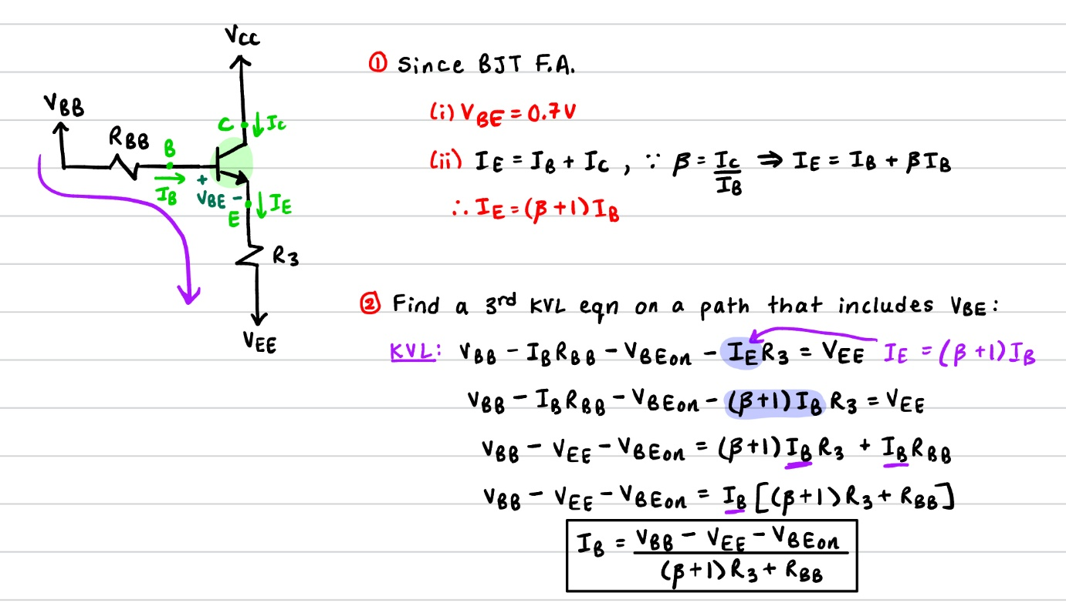
Q6. (10 Points)
(i) Comparing $I_{B}$ Expressions:
The main difference between equations 3 and 5 is the presence of $R_{3}$. Equation (3) does not contain $R_{3}$ because it was set to 0. Therefore, equation 5 contains the additional term $\left(β+1\right)R_{3}$.
$$\begin{aligned}I_{B}=\frac{V_{BB}-V_{EE}-V_{BEon}}{R_{BB}}\#\left(3\right)\end{aligned}$$
$$\begin{aligned}I_{B}=\frac{V_{BB}-V_{EE}-V_{BEon}}{\left(β+1\right)R_{3}+R_{BB}}\#\left(5\right) \end{aligned}$$
(ii) Deriving Equations:
Applying a change in power supply ${∆V}_{EE}$ to the equations above gives,
$$\begin{aligned}∆I_{B2}=\frac{V_{BB}-{(V_{EE}+∆V}_{EE2})-V_{BEon}}{R_{BB}}\#\left(3.1\right)\end{aligned}$$ | $$\begin{aligned}∆I_{B1}=\left[\frac{V_{BB}-{(V_{EE}+∆V}_{EE1})-V_{BEon}}{\left(β+1\right)R_{3}+R_{BB}}\right]\#\left(5.1\right)\end{aligned}$$
In equation 3.1, the change in power supply is directly related to the change in current $\left(V_{EE2}∝∆I_{B2}\right)$. Whereas the presence of $R_{3}$ in equation 5.1 reduces $∆I_{B1}$ because they are inversely proportional $\left(I_{B1}∝\frac{1}{R_{3}}\right)$.
Q7. (15 Points)
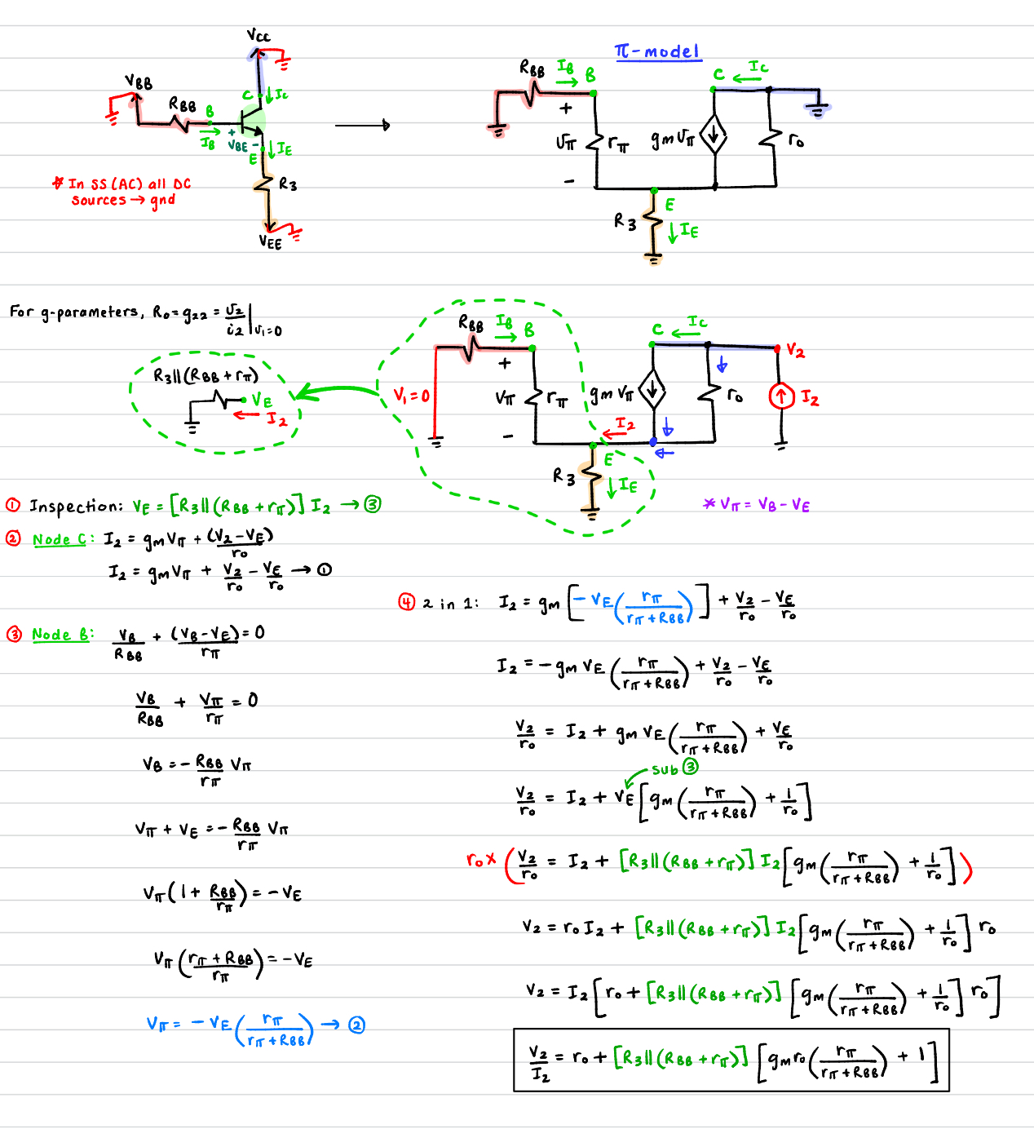

Q8. (10 Points)
When $R_{3}=0$:
$$\begin{aligned}V_{o,min}=V_{EE}+0.3V\#\left(1\right)\end{aligned}$$
Since $R_{3}≠0$, the voltage drop across this resistor needs to be considered. Thus, an additional factor of $V_{R3}=I_{E}R_{3}$ will be added to (1) to give us a new expression:
$$V_{o,min}=V_{EE}+I_{E}R_{3}+0.3V$$
Since $I_{C}=αI_{E}$ and $I_{C}=I_{o}:$
$$\begin{aligned}V_{o,min}=V_{EE}+\frac{I_{o}}{α}R_{3}+0.3V\#\left(2\right)\end{aligned}$$
This is illustrated in the figures below:
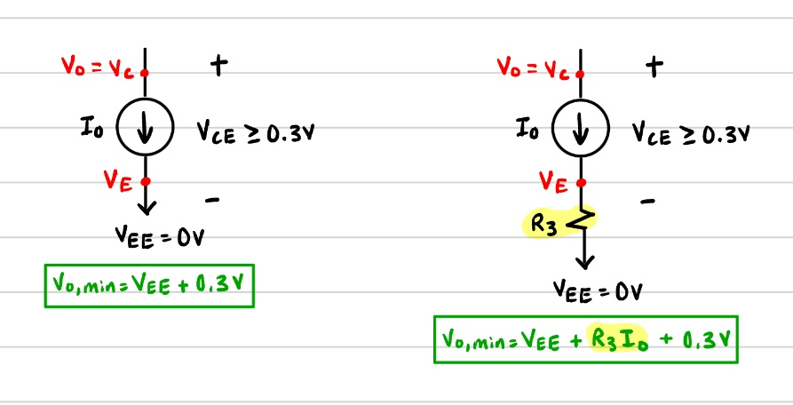  Fig 1. Ideal Current Sink when $R_{3}=0$ | Fig 2. Ideal Current Sink when$R_{3}≠0$ | 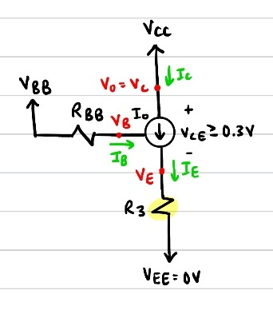  Fig 3. Real Current Sink when $R_{3}≠0$

Q9. (15 Points)
(i) Finding $R_{3}$:
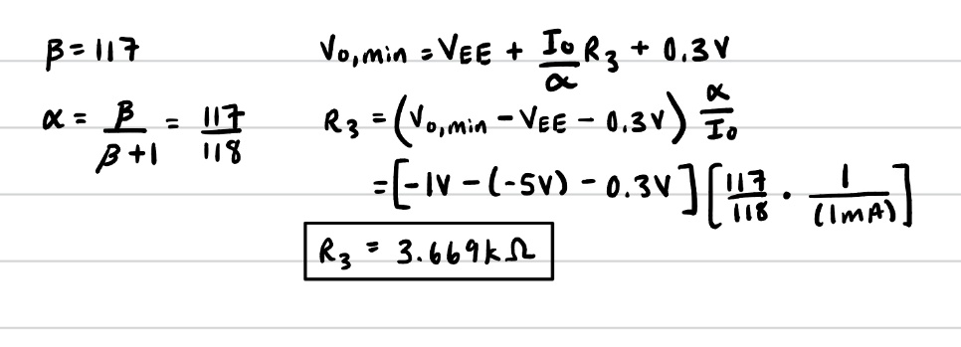

(ii) Finding $R_{1}$:
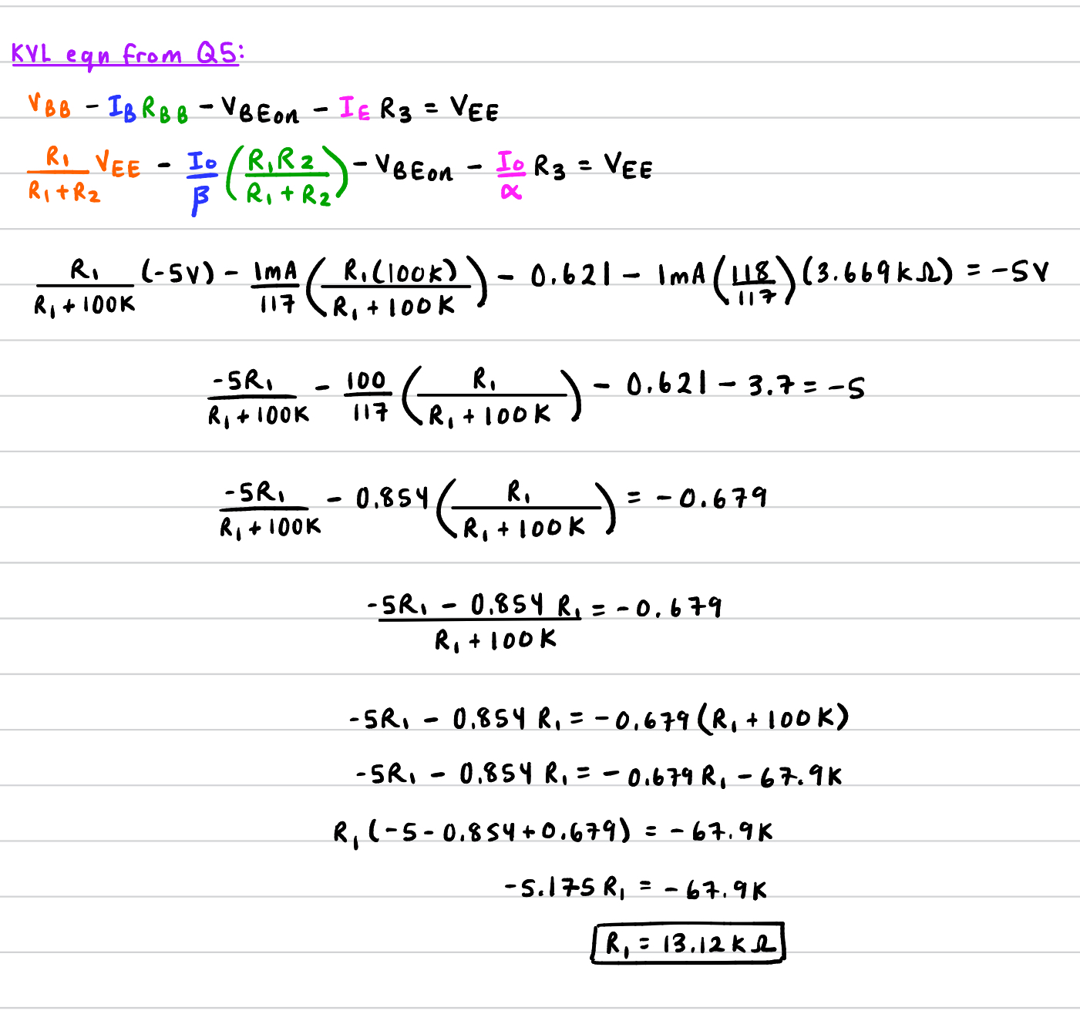

(iii) Verifying $I_{o}$ vs. $V_{CC}$ characteristics:
Below is a graph of the $I_{o}$ vs. $V_{CC}$ characteristics and the PSpice Schematic used to generate them.
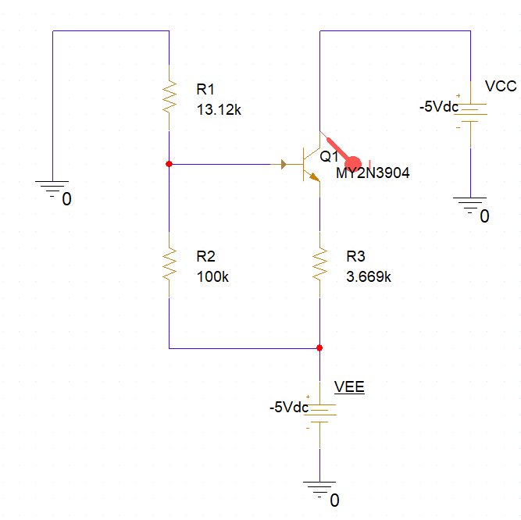
Fig 4. PSpice Schematic

Fig 5. $I_{o}$ vs. $V_{CC}$ characteristics
From Figure 5, it shows that when $V_{CC}=-1V=V_{o,min}$, $I_{o}$ saturates to the designed constant of 1.0mA. This was the desired outcome.

Q10. (10 Points)
Below is a graph of $I_{C}$, $V_{CC}$, $V_{E}$ and the PSpice Schematic used to generate them.
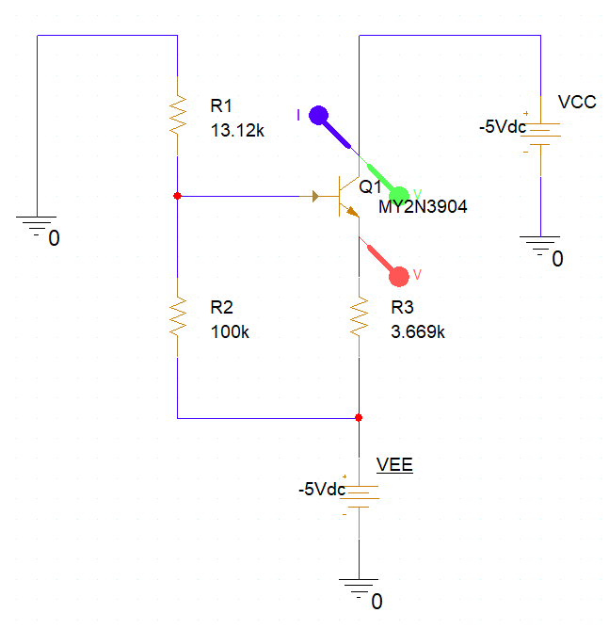
Fig 6. PSpice Schematic 2

Fig 7. Characteristics 2
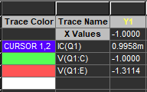
To determine $\left|V_{CE}\right|$, in Figure 7 we see that the BJT enters active mode at $V_{E}=-1.3114V$. The corresponding $V_{CC}$ value at this point is $V_{C}=-1V$ (see Figure 8) thus
$\left|V_{CE}\right|=V_{CC}-V_{E}=-1V-\left(-1.3114V\right)=0.3114V$
Since $\left|V_{CE}\right|≥0.3V$, this confirms that the BJT is operating in active mode.
Fig 8. Voltage values

